

**YEAR: 12**

**GENERAL BIOLOGY**

**Test 2 : Populations and Biodiversity**

**Please do not mark this paper.**

MULTIPLE CHOICE (15 marks)

1. A community is best described as;
   1. populations interacting in a habitat
   2. the interaction of populations and the environment
   3. the biotic components in a habitat
   4. the abiotic components in a habitat
2. Which graph shows a population that has reached its “carrying capacity”?

|  |  |
| --- | --- |
| a. | b. |
| c. | d. |

3) The market gardener was concerned that an increase in rabbits in the area would reduce the flower yield. Ecologists carefully monitored the rabbit population in the market garden area over 12 months. At the beginning of the year there were 2000 rabbits. During the year 1000 were born, 200 died, 100 new rabbits entered the area and 100 rabbits left the area. What was the rabbit population in the market garden area at the end of the year?

(a) 800 rabbits

(b) 2,800 rabbits

(c) 1200 rabbits

(d) 3,200 rabbits

4) Use the information in question 4 to calculate the overall rate of change in the rabbit population during the year.

(a) 400 rabbits per 1000 per year

(b) 800 rabbits per 1000 per year

(c) 1200 rabbits per 1000 per year

(d) 600 rabbits per 1000 per year

5) During one year, a population of 100 animals experiences these changes:

30 animals are born

10 animals emigrate

15 animals immigrate

20 animals die

What is the best estimate of the population size at the end of the year?

(a) 85

(b) 100

(c) 115

(d) 175

6) Which of the following statements is the best definition of carrying capacity?

(a) The largest population size that can be reached.

(b) The smallest population size that does not damage the environment.

(c) The smallest population size sustainable in a given habitat.

(d) The largest population size that the environment can sustain long-term.

7) A sudden flood kills half the population of deer in a mountain valley. Which of the following statements is the best definition of this type of population change?

It is a

(a) density-dependent population change.

(b) density-independent population change.

(c) carrying capacity-dependent population change.

(d) carrying capacity-independent population change.

8) Biodiversity can be described as:

(a) the variety within and between all species of plants, animals and microorganisms.

(b) the variety between members of a particular species.

(c) the variation found within a biome.

(d) the variation in number of species within a particular area.

9) Javan rhinos used to be the most widespread Asian rhinoceroses but the few left in the wild now live in two small national parks. The fact that this species lives nowhere else is an example of:

(a) a unique species.

(b) an introduced species.

(c) a phylogenetic species.

(d)an endemic species.

10) According to the biological species concept, a species consists of:

(a) individuals that can and do interbreed and are reproductively isolated.

(b) individuals that form the smallest cluster within a particular environment.

(c) individuals which are capable of breeding if they are put together artificially.

(d) individuals that have the same DNA and therefore behave alike.

11) Which of the following is true for r-selected species?

(a) They give little or no parental care.

(b) They have large eggs or offspring.

(c) They have a longer lifespan.

(d) There are few offspring in each reproductive cycle.

12) An ecologist is interested in measuring the abundance of wombats in a forest in eastern Victoria. Which method is she most likely to use?

(a) Random quadrats

(b) A series of transects

(c) Capture–mark–recapture

(d) Radio tracking

13) Which of the following is not a density-dependent factor which can limit animal populations?

(a) Weather conditions

(b) Competition for food

(c) Mortality rates

(d)Predation

14) Worldwide, the number of fish available for fishing has decreased due to:

(a) deforestation, which has decreased the nutrient run-off into the oceans.

(b) overexploitation.

(c) extinction, as they are no longer well adapted to their environment.

(d) secondary succession.

15) In the ocean around Tasmania, large kelp forests exist. Which of the following would most likely be the keystone species in these marine ecosystems?

1. Kelp
2. Sea urchins which feed on the kelp
3. Fish which feed on the kelp
4. Dugongs which feed on the kelp

**Year 12**

**General Biology**

|  |
| --- |
| Name: |
| Teacher: |

|  |  |  |  |
| --- | --- | --- | --- |
| **Task 9: Populations and Biodiversity Test** | | | Weighting 10% |
| Marks Received | Marks Available | Percentage | |
|  |  |  | |

Time Allocated:

Working time: 50 minutes

**Multiple Choice Short Answer Total**

**/39**

**/15**

**/54**



**TEST: Populations and Biodiversity**

**ANSWER BOOKLET**

**NAME:**

**FORM:** **DATE:**

**SECTION ONE:** Multiple choice answers

Cross (X) through the correct answer.

|  |  |  |  |  |
| --- | --- | --- | --- | --- |
| 1 | a | b | c | d |
| 2 | a | b | c | d |
| 3 | a | b | c | d |
| 4 | a | b | c | d |
| 5 | a | b | c | d |
| 6 | a | b | c | d |
| 7 | a | b | c | d |
| 8 | a | b | c | d |
| 9 | a | b | c | d |
| 10 | a | b | c | d |
| 11 | a | b | c | d |
| 12 | a | b | c | d |
| 13 | a | b | c | d |
| 14 | a | b | c | d |
| 15 | a | b | c | d |

**Short Answer Section (41 marks)**

16) In Bold park there is a population of Rainbow Lorikeets. Last year the population

growth rate was studied. The following data was collected;

emigration rate = 5% immigration rate = 10%

death rate = 4% birth rate = 20%

a) Calculate the population growth rate of the Rainbow Lorikeet. Show your working.

(2 marks)

b) Describe what is happening to this population. (1 marks)

____________________________________________________________________________

17) A biologist wished to estimate the population size of dragonflies around a swamp. On Day 1

of his study, he caught some dragonflies, marked each one with a tiny spot of paint on the

back and then released them where they had been caught. The next day (Day 2) he returned

and caught more dragonflies around the pond. Some of these were marked and some were

not marked. The results are shown below.

|  |  |  |
| --- | --- | --- |
|  | Dragonflies caught | |
|  | Day 1 | Day 2 |
| Number unmarked dragonflies captured | 20 | 22 |
| Number marked dragonflies captured | 0 | 10 |
| Total | 20 | 32 |

From the data above the population size of the dragonflies can be calculated using the formula:



where = the estimated population size



*n1* = the number of dragonflies caught and marked on Day 1

*n2* = the total number of dragonflies (marked and unmarked) caught on Day 2

*m* = the number of dragonflies caught on Day 2 that were marked on Day 1

Calculate the estimated population size of dragonflies around the swamp. Show your working. (4 marks)

18) A biologist wished to estimate the population size of acorn barnacles (small animals related to crabs) living in a 500m2 area of rocky coastline. Adult barnacles live permanently attached in one spot and do not move about. The biologist randomly placed 10 quadrats, each of 1m2, within the area and counted the number of barnacles within each quadrat.

|  |  |
| --- | --- |
| Quadrat | Number of barnacles |
| 1 | 12 |
| 2 | 17 |
| 3 | 8 |
| 4 | 3 |
| 5 | 26 |
| 6 | 4 |
| 7 | 14 |
| 8 | 6 |
| 9 | 9 |
| 10 | 11 |

Calculate the average number of barnacles per square meter in these samples. Show your working. (2 marks)

Use your answer in part (i) to estimate the population size of barnacles on 500m2 area of rocky coastline. Show your working. (2 marks)

Give two assumptions that you made to calculate the population size of the barnacles. (2 marks)

Assumption 1:

Assumption 2:

Why is a capture-recapture method not appropriate to estimate the population size of barnacles? (2)

19) The graph below illustrates the change in a Red Deer population on a fully fenced farm in the Outback. The farm originally had approximately 100 Red Deer. They fed on grasses, tree seedlings and shrubs. They shared their environment with rabbits and wallabies as well as the occasional fox and wild dogs. All known predators were eliminated before counting began. At a certain stage, a large pack of wild dogs entered through the fence, which was repaired soon after, but the effect of the wild dogs on the deer population was clearly visible.

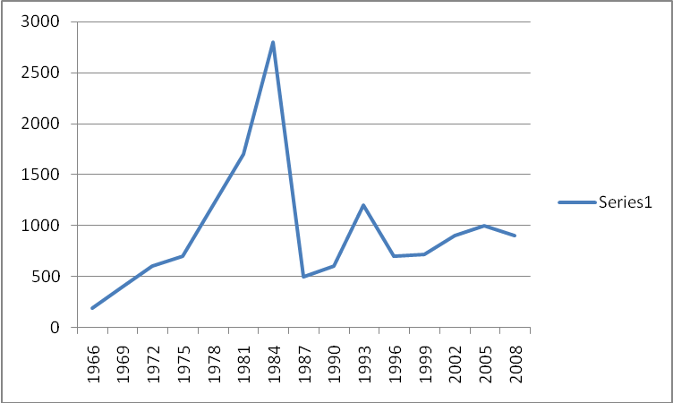

Carrying capacity

Time in Years

Number of Red Deer

1. Suggest TWO reasons for the population growth seen on the graph between 1975 and 1984.

(2 marks)

*____________________________________________________________________________*

*____________________________________________________________________________*

____________________________________________________________________________

____________________________________________________________________________

____________________________________________________________________________

1. During which year did the wild dogs enter the fenced area? Give a reason for your answer

from the information provided.

(2 marks)

____________________________________________________________________________

____________________________________________________________________________

____________________________________________________________________________

1. Between 1987 and 1993 the deer population increased again. Mention a possible reason

for this increase.

(1 marks)

___________________________________________________________________________

___________________________________________________________________________

___________________________________________________________________________

1. What method of sampling was most probably used to determine the size of the deer a population? Justify your answer. (2 marks)

___________________________________________________________________________

___________________________________________________________________________

___________________________________________________________________________

1. Do you think the line representing carrying capacity is accurate? Give a reason for your answer. (2 marks)

____________________________________________________________________________

____________________________________________________________________________

____________________________________________________________________________

____________________________________________________________________________

1. The population of deer appears to have stabilised between 2002 and 2008. Suggest how the farmer might be controlling the population. (1 mark)

____________________________________________________________________________

1. Causes of population change include density dependent and density independent

factors. Describe these factors and give examples. (4 marks)

____________________________________________________________________________

____________________________________________________________________________

____________________________________________________________________________

____________________________________________________________________________

____________________________________________________________________________

____________________________________________________________________________

1. **Define** biodiversity and give one reason why it is important in a sustainable natural ecosystem. (2 marks)

_____________________________________________________________________________

_____________________________________________________________________________

_____________________________________________________________________________

1. **Describe** four major ways in which humans damage ecosystems. (4 marks)

____________________________________________________________________________

____________________________________________________________________________

____________________________________________________________________________

____________________________________________________________________________

____________________________________________________________________________

____________________________________________________________________________

____________________________________________________________________________

____________________________________________________________________________

1. **Clarify** two reasons why natural ecosystems should be protected. (4 marks)

____________________________________________________________________________

____________________________________________________________________________

____________________________________________________________________________

____________________________________________________________________________